Diocesan Sponsorship 2022
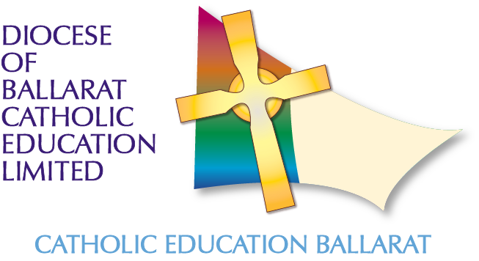
Diocesan Sponsorship
Sponsorship is on the basis of:
1/3 CEB contribution;
1/3 School contribution and
1/3 Participant contribution
except where Accreditation to teach Religious Education is the reason for the study. In these cases, CEB contributes 2/3 of cost and the school contributes 1/3.
Sponsorship is for the cost of unit fees and does not include student amenities fees.

Priority Courses 2022
- Graduate Certificate in Teaching Religious Education (CTC and/or YTU) (REAP 2021-2022 Cycle)
- Graduate Certificate Catholic Studies (ACU)
- Master of Theology (Research) (ACU)
- Master of Theological Studies (ACU)
- Master of Professional Studies in Theology (ACU)
- Master of Religious Education (ACU)
- Master of Educational Leadership (ACU)
Requirements:
Usually, sponsorship for Masters’ courses, can only be provided to applicants that have Accreditation to Teach and to Teach Religious Education or Lead in Catholic Schools in Victoria. (CECV)

Applications close:
Monday 1 November 2021
Successful applicants will be informed by:
Friday 3 December 2021

Priority Course 2022

Course Title………….……………………………………………University…………………..…
Title………… Surname…………………………….. First Name: ………………………………………
School……. E number………
School Location:
Your Leadership Role:
Email: Phone:
Accreditation to Teach Religious Education in a Catholic School: Number
Units (name, code. cost) to be undertaken in 2022 (maximum of two):
Unit 1 (name)…………………………………………………(code)……………. (cost)…………...

Unit 2 (name)…………………………………………………(code)……………...(cost)…………...
Did you receive sponsorship in 2021? ………… If yes, attach evidence of completion.
Please complete the following questions to assist the Panel in their decision making. In 150 words per question, what will participation in this study mean for:
- You…

- The School...

- Catholic Education…

Please note - it is important that you complete ALL the above statements as requested.

- I have read the Policy and Procedures documents: Sponsorship: Higher Education Studies.
- I understand that:
- I will be making a personal contribution of one-third of the cost of the Sponsorship, unless undertaking study to complete my Accreditation to teach Religious Education

- The cost of the sponsorship will not be finalized until evidence of unit enrolment and unit fees are provided to CEB

- The required units with a Catholic perspective will be undertaken to complete the degree.

Applicant Signature: Date:

PRINCIPAL’S ENDORSEMENT

I endorse this application from
I agree to make a school contribution of one-third of the cost and understand that the participant is also required to contribute one-third of the cost personally, unless undertaking study for accreditation to teach Religious Education.

Surname: …………………………………………………… First Name: ……………………………………………………………

Principal Signature: Date:

School & Location: .

Please return via email by Monday 1 November 2021 to:

Attention:
Dr Andrew Watson
Catholic Education Ballarat
Email: awatson@dobcel.catholic.edu.au
Phone: 0417 156 656

