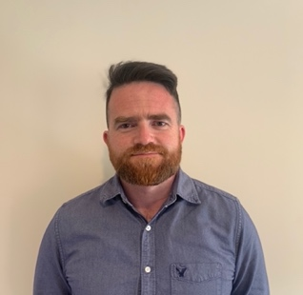David Murphy

PME, BA, PD

Treanmore

Mohill

Co. Leitrim

Ireland

+353 879119670 [davemurph090981@gmail.com](mailto:davemurph090981@gmail.com)

Irish Teaching Council Number: 243037

______________________________________________________________________________

Profile

Professional Master of Education in the subjects of History and Geography, with a Bachelor of Arts in History and a Professional Diploma in teaching English. Ten years teaching experience in both Irish and international schools, working with students across a wide range of ages and nationalities. A friendly and caring teacher with a passion for contributing to all aspects of school life, and with a keen interest in inspiring young people to excel in all areas.

Education

2021 – 2023 Professional Master of Education Maynooth University, Ireland

2018 – 2019 Professional Diploma in Teaching English Abu Dhabi University, UAE

2009 – 2012 Bachelor of Arts Maynooth University, Ireland

Experience

**Lough Allen College, County Leitrim, Ireland**  **August 2022 – Present**

*Placement Secondary School Junior and Senior Cycle Teacher*

* Teaching junior and senior cycle history, and junior cycle geography
* Planning units of learning in accordance with Irish education learning outcomes
* Participation in different areas of school life, including sport and event organisation

**Elphin Community College, County Roscommon, Ireland** **August 2021 – June 2022**

*Placement Secondary School Junior Cycle Teacher*

* Teaching in the subjects of junior cycle history and geography
* Supporting teaching staff through class substitutions
* Involved in various school workshops and excursions

**ISC DIP, Dubai Investments Park, Dubai, UAE August 2019 – June 2021**

*Primary Teacher*

* Grades 3, 5, and 6 as an English and Social Studies teacher
* Focus on student performance and academic achievement
* Weekly invigilation and marking of exams, while working to a 30-hour timetable

**Ruwais Private School, Abu Dhabi, UAE August 2013 – June 2019**

*Primary Teacher*

* Grades 4, 5 and 6 as an English and Social studies teacher
* Emphasis on high academic achievement
* Participation in school activities, including sports days and excursions

Professional Development

* Apple Teacher Certificate for IPAD
* Continuing Professional Development through Irish Junior Cycle History workshops
* University modules in restorative practice
* Child Protection

References

Ms. Breda Ryan, Regional Head of Primary English, ISC DIP, Dubai, UAE

Tel +971 50 583 7559 Email: [bryan@iscdip.sabis.net](mailto:bryan@iscdip.sabis.net)

Mrs. Siobhan Cullen, Principal of Elphin Community College, County Roscommon, Ireland

Tel +353 86 074 8059 Email: [siobhan.cullen@gretb.ie](mailto:siobhan.cullen@gretb.ie)

Mrs. Fiona Kuehl, Principal of Lough Allen College, Drumkerran, County Leitrim, Ireland.

Tel +353 86 418 3299 Email: [fionakuehl@msletb.ie](mailto:fionakuehl@msletb.ie)

Mrs. Sarah Timmins, PME Coordinator, Maynooth University, Co Kildare, Ireland.

Tel +353 87 671 7142 Email: [Sarah.Timmins@mu.ie](mailto:Sarah.Timmins@mu.ie)