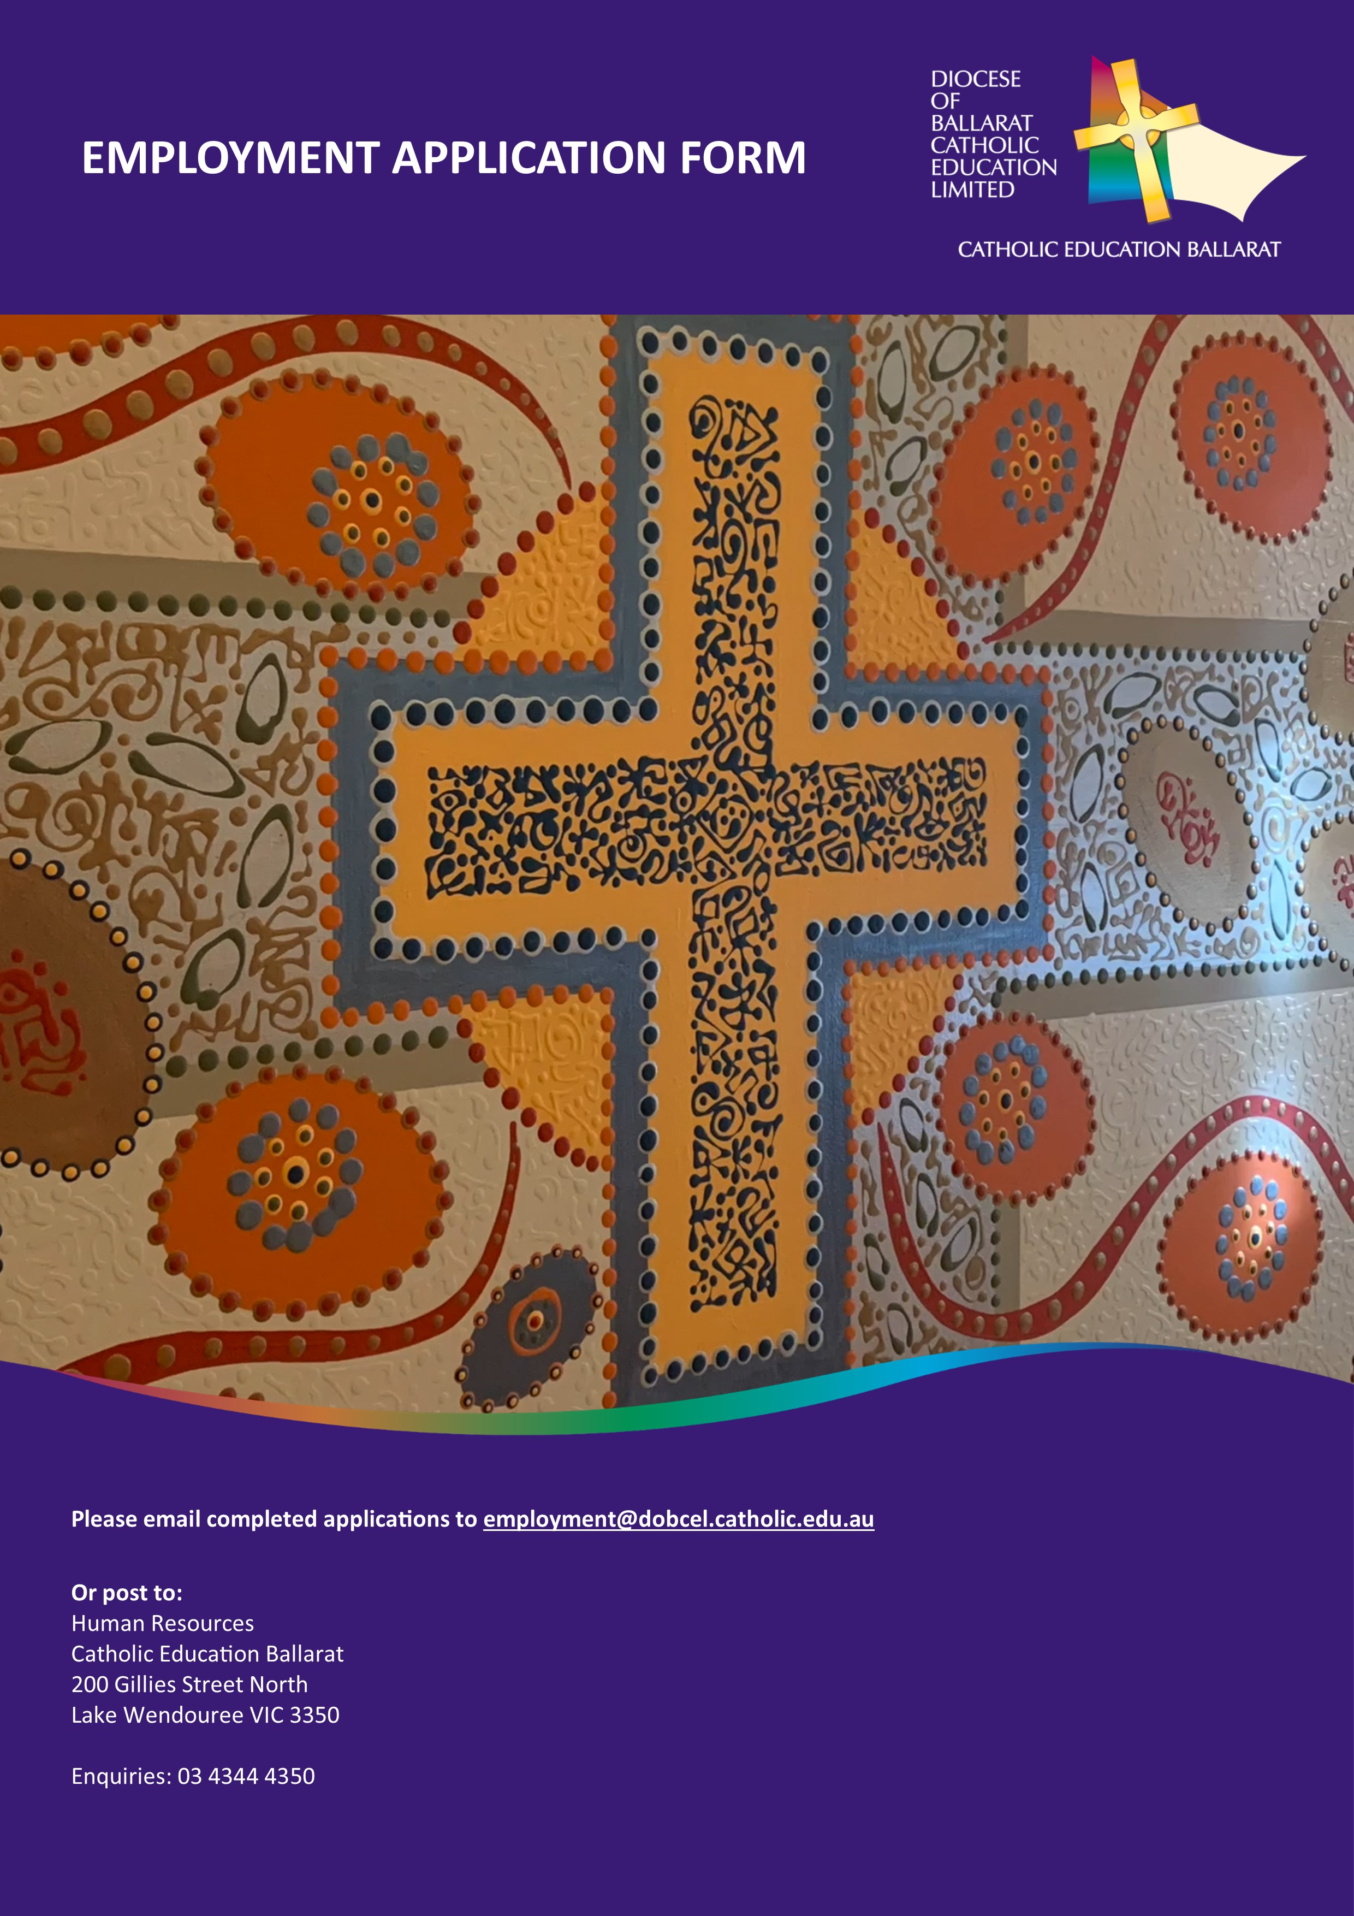

Employment Collection Notice

Diocese of Ballarat Catholic Education Limited (DOBCEL) is a company that governs the Catholic schools in the Diocese of Ballarat. It delegates the management of these schools to catholic Education Ballarat (CEB).

In applying for a position with Catholic Education Ballarat you will:

- provide DOBCEL with personal information to assess your application and suitability. This information may be kept on file;

- if the personal information that is requested on the application form is not provided, the application cannot be considered.

- you agree that DOBCEL may store this information until the end of the current year;

- information concerning you may be collected from other parties. These will most commonly be those referees you have nominated, but the selection panel does reserve the right to contact other parties who may be able to assist in their deliberations;

- if you provide us with the personal information of others, we encourage you to inform them that you are disclosing that information. The third party can access their information;

- you may seek access to your personal information. However, there may be occasions when access is denied. Such occasions would include where access would have an unreasonable impact on the privacy of others;

- we may disclose your personal information to the following types of organisations: other schools, State and Federal Government Departments, the Victorian Catholic Education Commission, the Diocese of Ballarat and parishes, schools within other diocese, our insurers and medical practitioners. DOBCEL employees will not disclose information about you to any other third party without your consent;

The CEB can be contacted at 200 Gillies Street, Lake Wendouree, or phone 03 4344 4350.

Commitment to Safeguarding of Children and Young People
DOBCEL is committed to child safety and is legally required to obtain the following information about a person applying to undertake a role connected to children and young people:
- Working with Children Check status, or similar check
- Proof of personal identity and any professional or other qualifications
- Any criminal or investigation history that could impact on child related work
- References that address the person’s suitability for the job and working with children.

Application Form
This application form should be accompanied by:
- Application cover letter
- An evidence-based statement addressing the key selection criteria/mandatory requirements
- Curriculum vitae

Position
Which role you are applying for
How did you hear about this opportunity? (Newspaper, website etc)

Personal Details
Given Name/s
Surname
Address
City
State
Postcode
Email Address
Home Number
Mobile Number
VIT Registration Number (or N/A)

Education
TERTIARY LEVEL QUALIFICATIONS
Qualification Gained | Institution Attended | Years Attended | Date Awarded
CURRENT TERTIARY STUDY BEING UNDERTAKEN (attach evidence of enrolment)
Qualification Gained | Institution Attended | Years Attended | Date Awarded

ANY RELEVANT RECENT TRAINING / COURSE / QUALIFICATION
Qualification Gained | Institution Attended | Years Attended | Date Awarded

Nominated Referees
CURRENT EMPLOYER
Name |  | Position
Organisation |  | Email
Phone |  | Mobile

PROFESSIONAL REFEREE 1
Name |  | Position
Organisation |  | Email
Phone |  | Mobile

PROFESSIONAL REFEREE 2
Name |  | Position
Organisation |  | Email
Phone |  | Mobile

PRE-EMPLOYMENT DISCLOSURE QUESTIONS

Child Related Work
Have you ever been the subject of an allegation or investigation via the Commission for Children and Young People (CCYP), under the Reportable Conduct Scheme? | Yes  No
If Yes, please give a brief description:

Have you ever been accused of physically, sexually or emotionally harming a child or a young person? | Yes  No
If Yes, please give a brief description:

Have you ever been the subject of an Apprehended Violence Order (AVO) that was made for the purpose of protecting a child or young person? | Yes  No
If Yes, please give a brief description:

Employment
During the last 5 years have you been the subject of formal performance management and/or disciplinary proceedings, or any action that might lead to such proceedings? | Yes  No
If Yes, please give a brief description:

Have you ever been suspended, dismissed or asked to resign from your position? | Yes  No
If Yes, please give a brief description:

Unlawful Activity
Have you been convicted of any criminal offence, including where no sentence was imposed? | Yes  No
If Yes, please give a brief description:

Have you been charged with and criminal offence, including where the charge has been withdrawn or you were acquitted of the offence? | Yes  No
If Yes, please give a brief description:

Health
Is there any reason why you would not be able to undertake the full inherent requirements of the position? | Yes  No
If Yes, please provide relevant details:

Pursuant to s41 of the Workplace Injury Rehabilitation and Compensation Act 2013 (WIRC Act) it is requested that you disclose any pre-existing injuries and diseases suffered by you, of which you are aware, and could reasonably be expected to foresee could be affected by the nature of the role.
Please provide details:

Additional Information for Disclosing Pre-existing Injuries/Diseases
Section 41 (2) of the Workplace Injury Rehabilitation and Compensation Act 2013 (WIRC Act) will apply to a failure to make such a disclosure or the making of a false or misleading disclosure. Section 41 (2) states:
If this subsection applies, any recurrence, aggravation, acceleration, exacerbation or deterioration of the pre-existing injury or disease arising out of or in the course of or due to the nature of employment with the employer does not entitle the worker to compensation under this Act.
Any information provided on this form will be used for the purposes of Section 41 of the Workplace Injury Rehabilitation and Compensation Act 2013 (WIRC Act) only.

Applicant Declaration

I declare

- There is no reason I am not suitable to work in child-related employment.

- The information provided in the application form is complete and correct in every detail, and I understand that deliberate inaccuracies or omissions may result in non-acceptance of my application and/or termination of employment.

- I consent to the prospective employer making inquiries of any current and/or previous employers in connection to the information and answers I have provided in this form. Inquiries made will be to verify the accuracy of the information in this form and to confirm my ability to carry out the inherent requirements of the position, including my suitability to perform child-connected work.

- I understand that wilful suppression, inaccuracy or non-disclosure of relevant health information may result in non-acceptance of this application and/or termination of employment. If further health information is required I may be asked to authorise the obtaining relevant medical information.

- If I have made a false or misleading disclosure, I may not be entitled to any compensation under the Workplace Injury Rehabilitation and Compensation Act, if the pre-existing injury or disease is aggravated or otherwise adversely affected by, or in connection with, the role.

- I understand that all applicants are required to undergo background screening including a National Police Record Check and Working with Children Check. I consent to such screening and checks in connection with my application for employment.

- I understand and accept that my appointment to this position requires a commitment to Catholic Education.

- I have read and understand the Statement of Principles regarding Catholic Education.

Signature
Date

DOBCEL Governance
The appointment of staff is conducted according to DOBCEL policy and procedures.

The Executive Director of Catholic Education Ballarat is the delegated authority to appoint all CEB staff. The facilitation of the selection process has been delegated to the Manager, Human Resources in liaison with the relevant Team Leader.

Appointments are made by the Executive Director of Catholic Education following a process of advertising, shortlisting, interviewing and recommendation by an appropriately constituted interview panel.

Catholic Education Ballarat employees participating in recruitment and appointment processes, will always observe those procedures and your confidentiality.

Application Procedure
Applications must include:

- A completed Application Form
- A professional Curriculum Vitae including full employment history and positions of leadership (no more than 4 pages)
- A response to the key selection criteria of no more than 4 pages

Applicants must also ensure they meet the requirements for the role outlined in the Role Description.

Communication
Your application will be acknowledged within 2 days of being received.
You will be informed of the progress of your application within 7 days of the application closing date.

Enquiries can be directed to:
Human Resources
03 4344 4350

Selection Panel
Proceedings of the selection panel are confidential, and no information gained from applicants shall be divulged to any person outside the recruitment process or the Executive Director.

Interviews
If you are selected for an interview, you will be contacted to arrange a suitable time, date and location. You will be given at least three (3) full working days’ notice and will be advised of any additional requirements.

Referees
You are required to provide the details of three professional referees with your application. Please ensure you inform your referees that they may be contacted to provide a reference on your behalf.
The selection panel has an obligation to obtain as much credible information as possible about each of the candidates to enable it to make an informed recommendation. If further references are required, a member of the interview panel will contact you to discuss this.

Completed reference checks will be held with an application until the end of the current year, at which time they will be destroyed or kept on the employee file.

Working with Children Check
It is preferable that applicants have a valid Working with Children Check (WWCC) at the time of applying for a role or being invited for an interview. Applicants without a valid WWCC will be ineligible to receive an offer of employment.
NB: Not applicable for Teachers with a current VIT registration.

National Police Record check
If you are the successful applicant, you will be required to undertake a National Police Record check to determine your suitability for employment.
Please note, persons who have a conviction for a relevant criminal offence (sexual, drug related and violence offences) are prohibited from working with children.
Relevant Criminal History, Apprehended Violence Orders and Prior Employment Checks, including relevant Disciplinary Proceedings, will be conducted on recommended applicants. The purpose of this check is to exclude or deter people who are clearly unsuited to working with children.

200 Gillies Street North, Lake Wendouree VIC 3350
P 03 03 4344 4350 | E employment@dobcel.catholic.edu.au | W dobcel.catholic.edu.au

